**Project**

We will try to do minor project on this update and rollback in deployments.

We have created a deployment file before.

First lets check there are no objects created in the cluster. Run the kubectl create command for deployment.

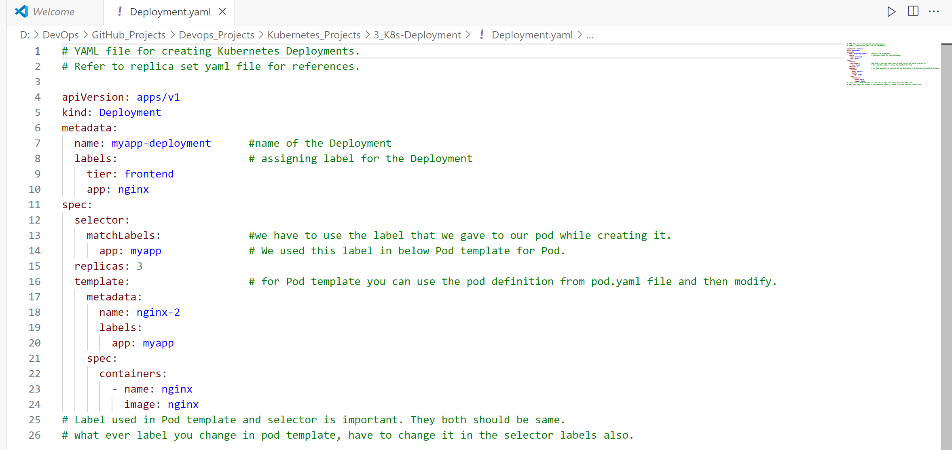**Roll out strategy:****Delete the Deployment: **Create Deployment again and check the status of rollout this time: 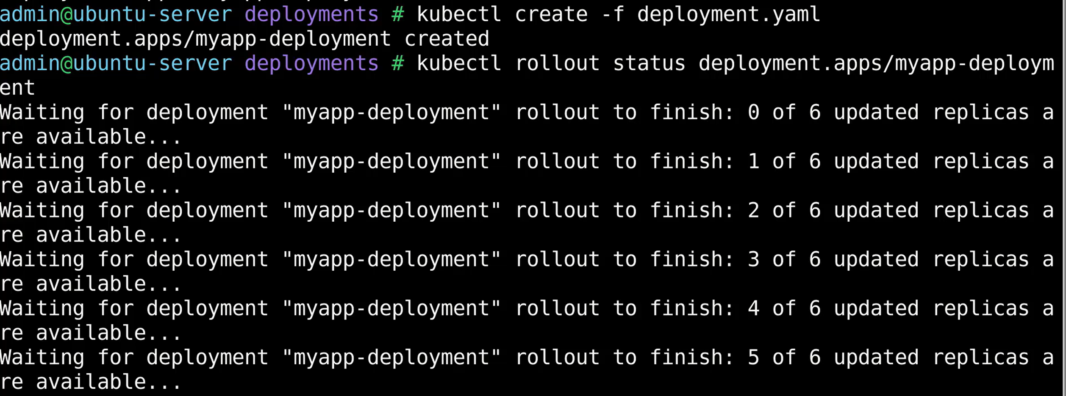It tries to bring up pods one at a time. To check the history of deployments: 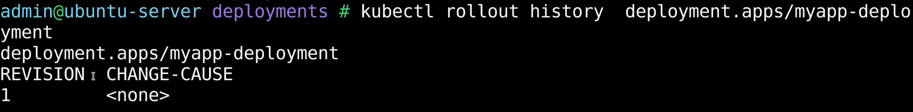Delete the deployment again: 

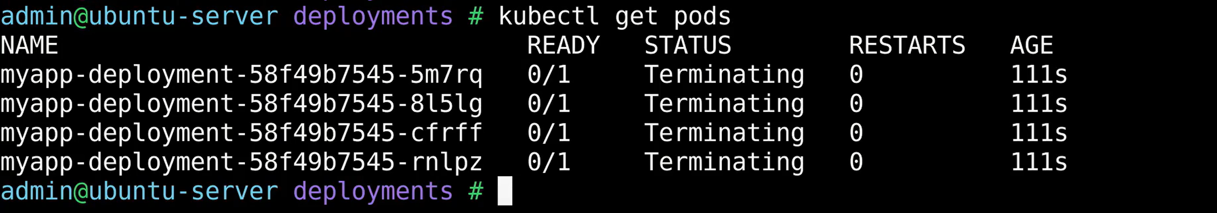Create Deployment again with record option. 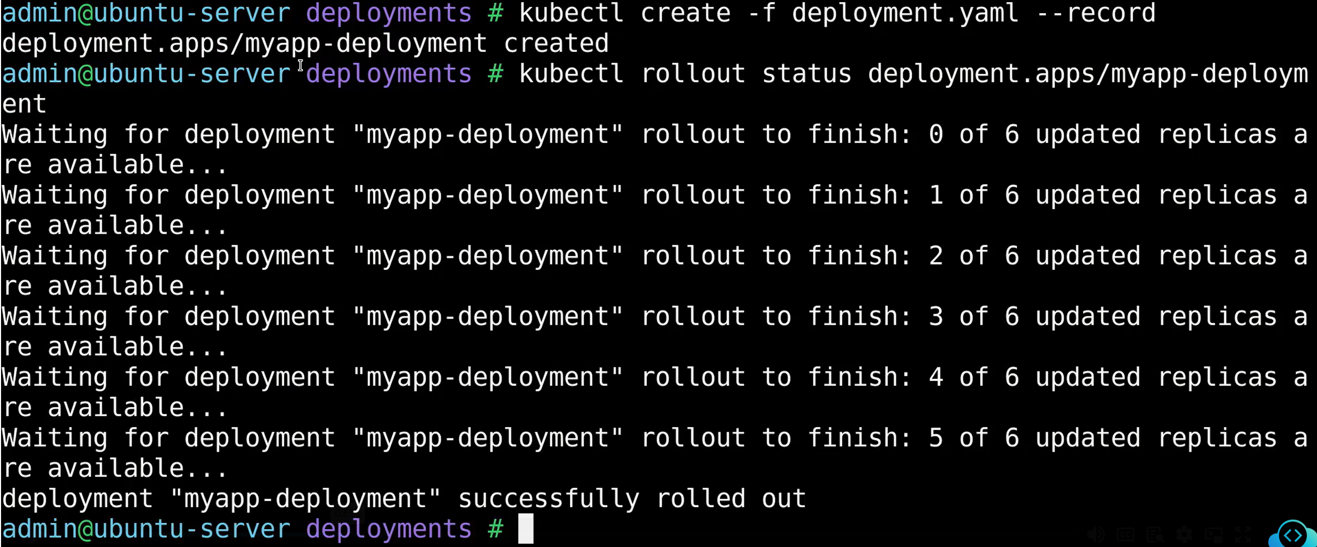Now check the history again: 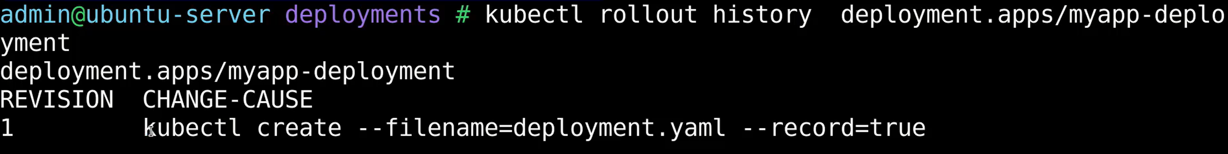**Update:** Now lets update the nginx version to lower version in deployment file: 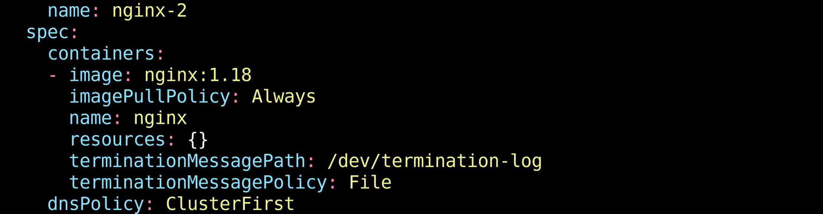Take help from docker hub to check for lower version number: 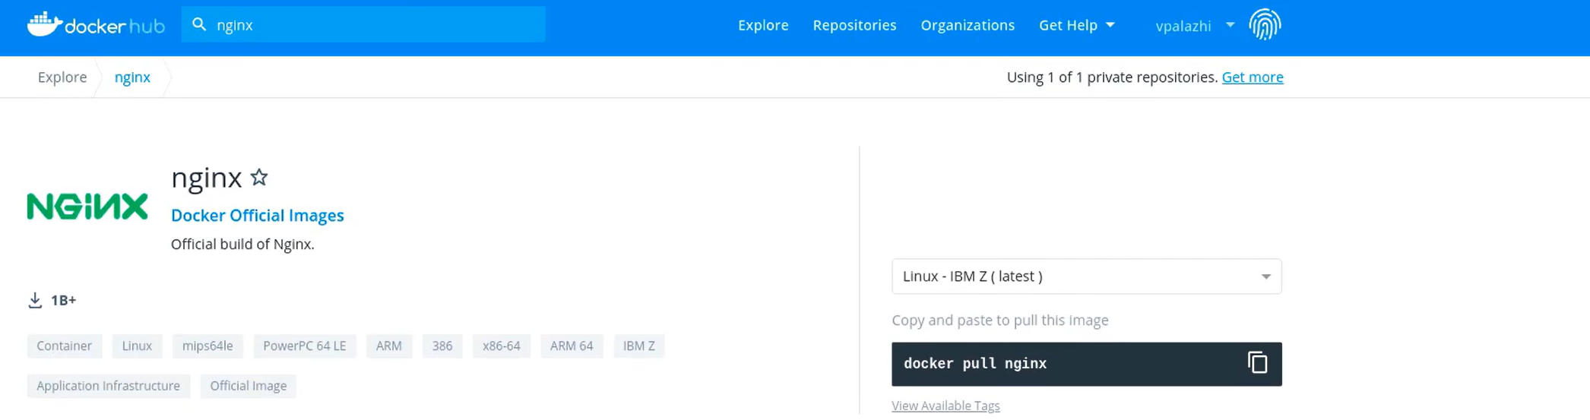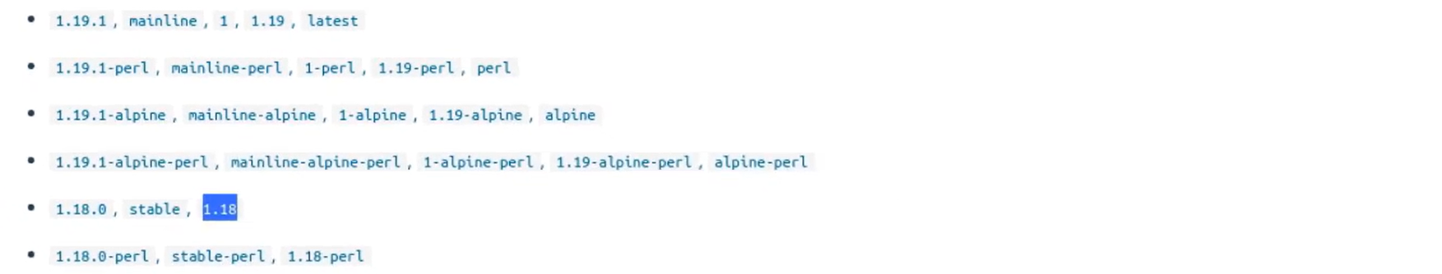

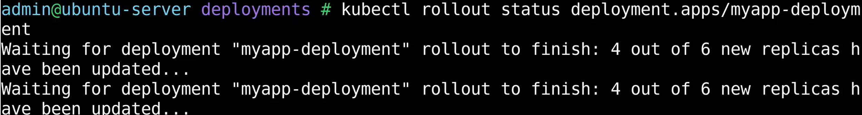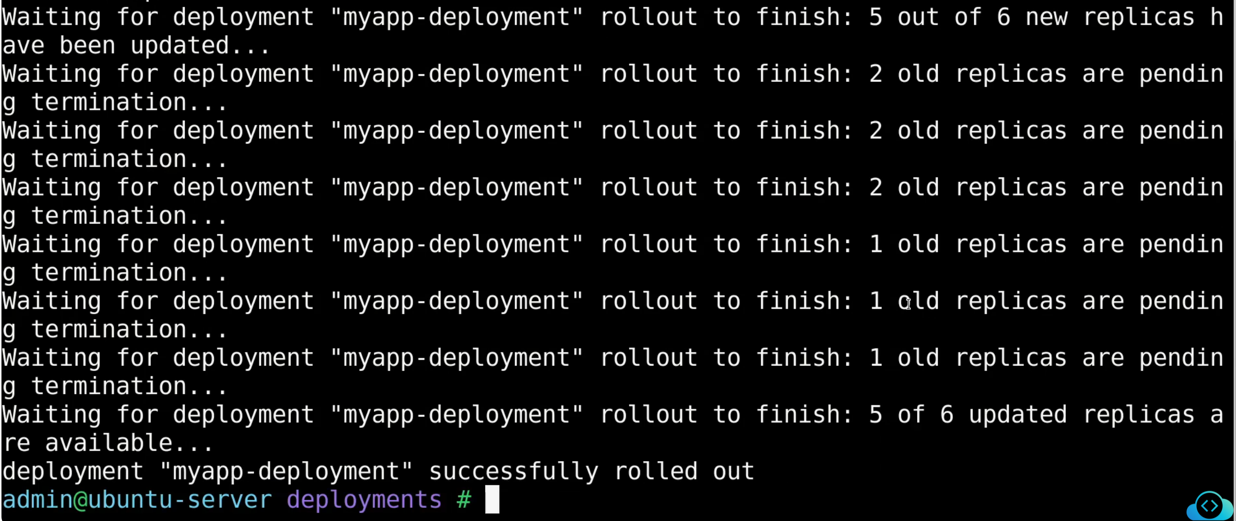You can see old replicas are being destroyed and new replicas being created one after another. Run this below command to see the same thing under events sections. 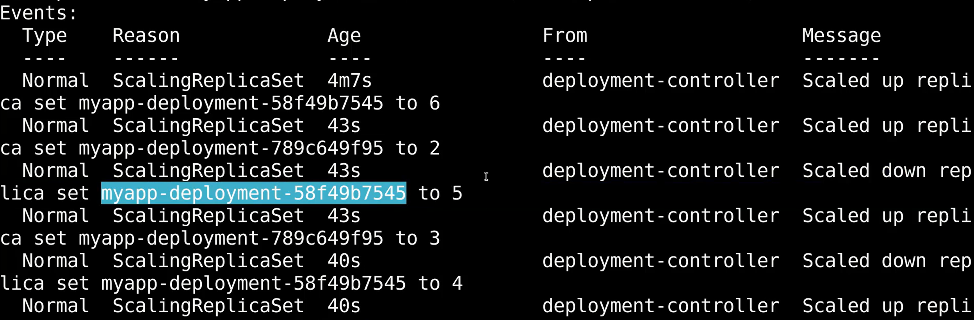Changing and recording the changes to image. Now do the rollout. Old replicas will be destroyed and new one will be up and running.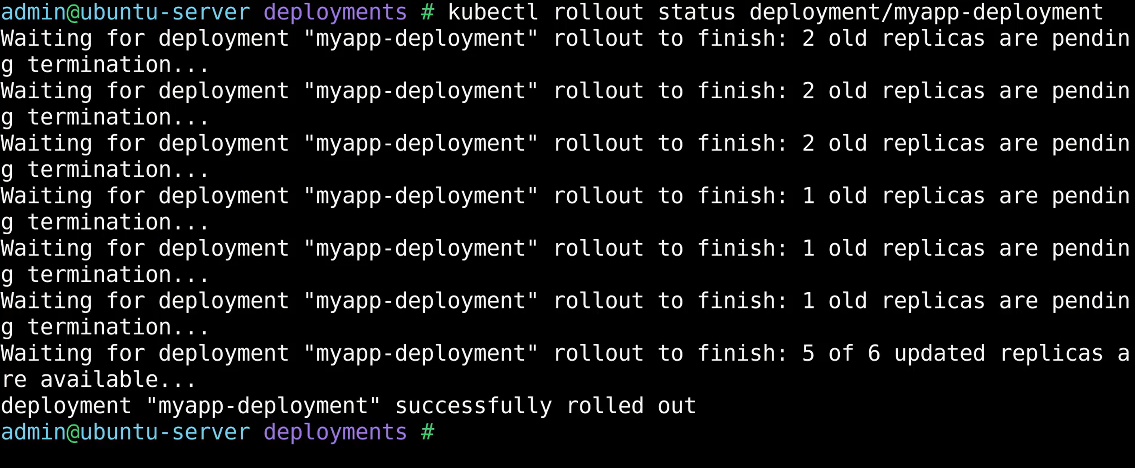

Now, check the history again: 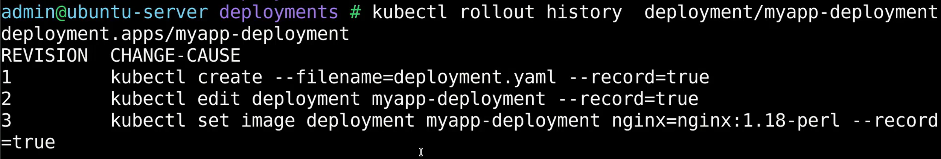You can see revision is created for every every rollout. We can see pods list also in below image. 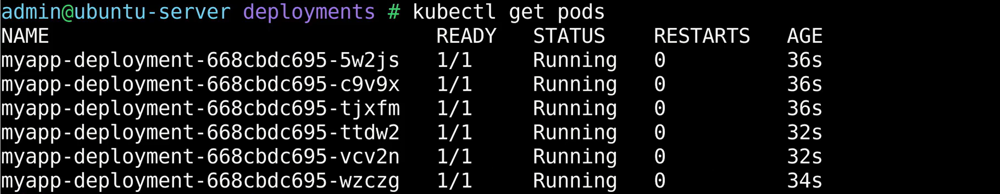**Roll back:** We have to revert back to previous version of deployment now. Check the status using status command: 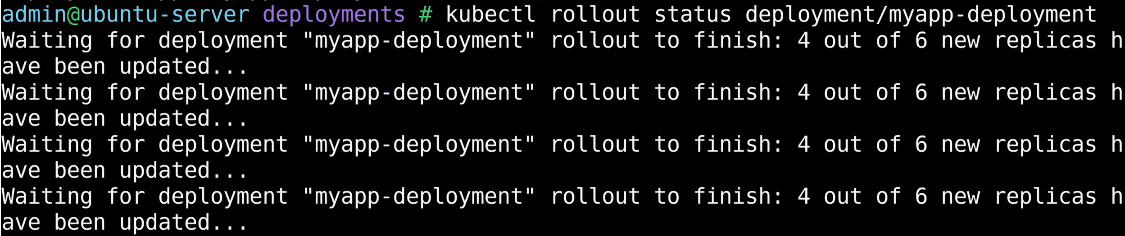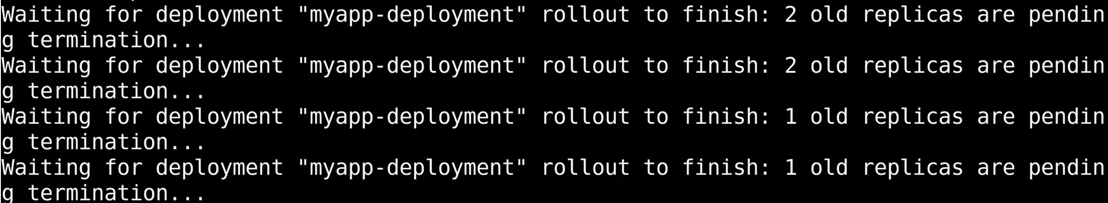It is bringing down the old replicas of revision 3 and then reverting back to revision 2 where nginx imahe version will be 1.18. Now check the history again: 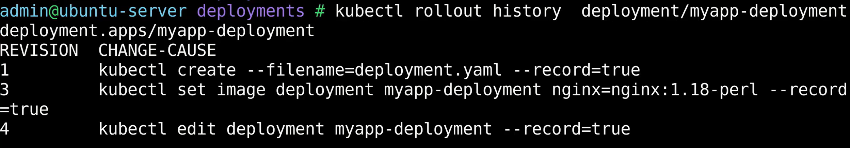We will have the three revisions in total. There is a new revision is created which is number 4. Revision 2 is gone. That is because revision 4 is essentially the revision 2. So, its reverted back to the same stage revision 2.